Creating EC2 images:

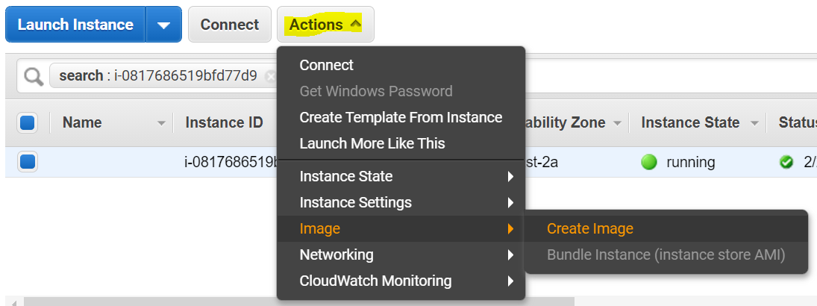

Give the details to create images:

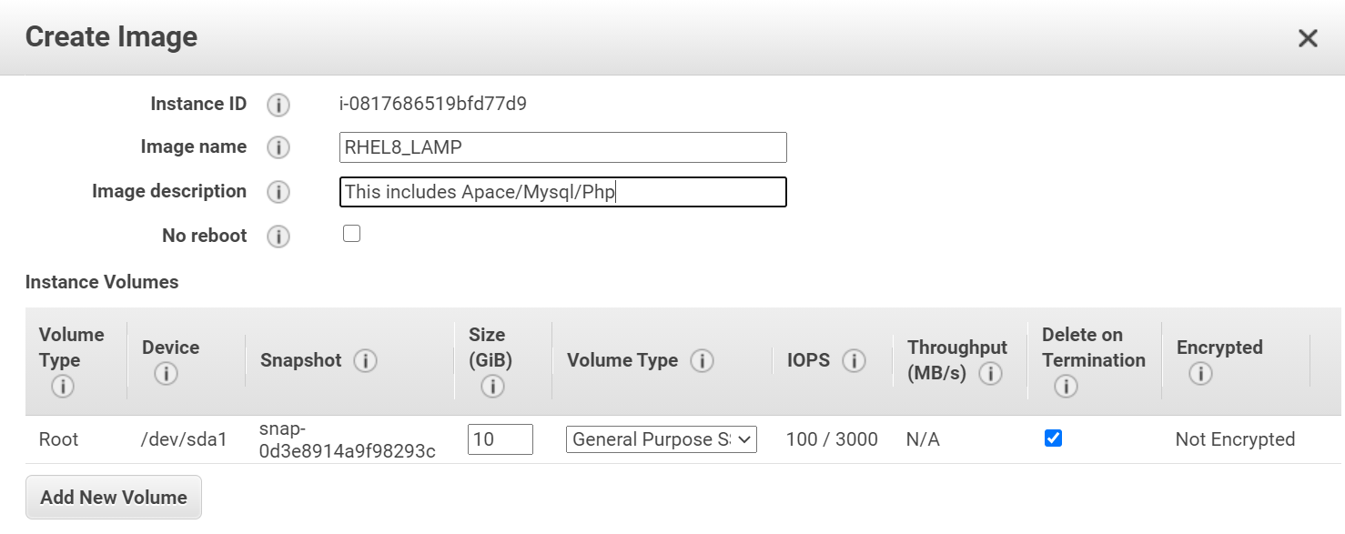

Image status is pending:

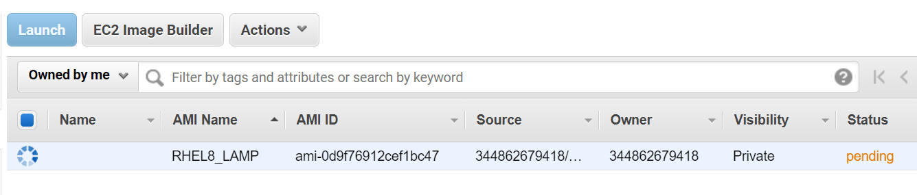

AMI process completed:

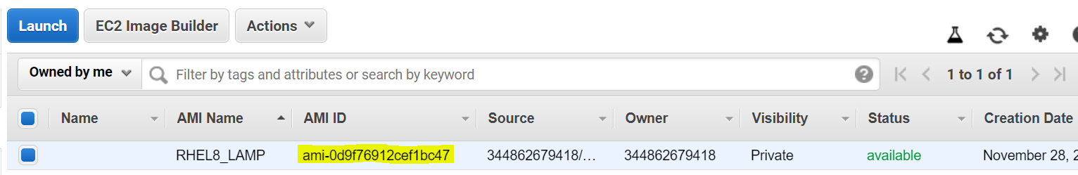

Now our new AMI is available in **My AMI** path

